**Experiment: 10**

**A case study on designing a network for an organization (college campus)**

**Aim:** To study a design of simple college network.

**Objectives:**

1. Identifying the networking devices.
2. Configurations on internetworking devices such as IP addressing, Routing Protocol (static routing), VLAN (Virtual Local Area Network) and NAT (Network Address Translation).
3. Services to be used such as FTP (File Transfer Protocol), Web server and DNS (Domain Name Service) server.

**Introduction:**

Figure 1 shows a simple college network design. The internal network of the college uses star topology. One central core switch is used to connect to all the departments. There are three departments Admin, INFT and CMPN shown in the network. The network is scalable and allows to add more number of departments as per need.

Each department can have more than one labs as shown. Number of labs also can be scaled as per the need. The network uses one router to connect to the Internet.

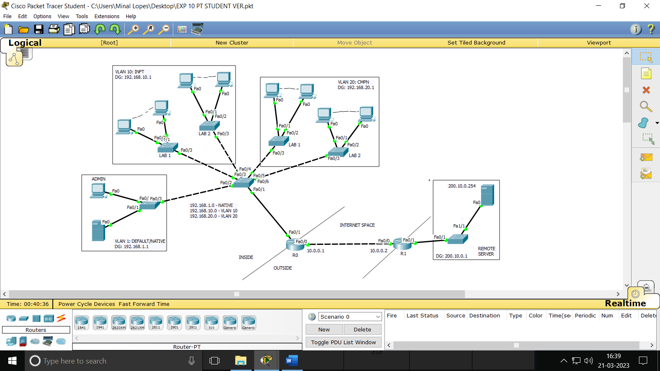Figure 1: Simplified college campus network

The network also has a remote site (Remote server) connectivity via Internet. The college network uses concept of VLAN for optimizing number of networking devices. The Admin section uses default VLAN, whereas, VLAN 10 is dedicated to INFT department and VLAN 20 is dedicated to CMPN department. To simplify the IP addressing, the entire network is assigned class C addresses with subnetting. The college network is hosting one web server (e.g. sfit erp) for web services.

**Procedure:**

Use following steps to configure the above College Campus Network.

Step 1: Drag required network devices. (Choose VLAN enabled router) (Choose 24 port switches for labs and normal switches at other places)

Step 2: Complete connections and define VLANs.

Step 3: Decide the LAN IP addresses. Complete PC configuration.

Step 4: Define VLANs in switch configuration and define trunk port and access port for switch.

Step 5: Define VLANs in router database. (Same as switch)

Step 6: Configure static routes on both the routers using following commands. The “0.0.0.0” ip address indicates that traffic coming from any ip address of college network has to be routed to ‘Internet’ interface of the router. Similarly, the traffic coming from any IP address of the remote site has to be routed to ‘Internet’ interface of corresponding router.

command for router 0:

Router(config)# ip route 0.0.0.0 0.0.0.0 Fa0/0 // to be used in CLI

command for router 1:

Router(config)# ip route 0.0.0.0 0.0.0.0 Fa0/0 // to be used in CLI

Step 7: To configure Trunking on Router 0 Interface.

Router#conf t

Enter configuration commands, one per line. End with CNTL/Z.

Router(config)#int Fa0/1

Router(config-if)#int Fa0/1.1 // **assign sub interface to INFT department.**

Router(config-subif)#

%LINK-5-CHANGED: Interface FastEthernet0/0.1, changed state to up

%LINEPROTO-5-UPDOWN: Line protocol on Interface FastEthernet0/0.1, changed state to up

Router(config-subif)#encapsulation dot1q 10 // configure encapsulation for VLAN 10

Router(config-subif)#ip address 192.168.10.1 255.255.255.0

Router(config-subif)#exit

Router(config)#int Fa0/1.2 // **assign sub interface to CMPN department.**

Router(config-subif)#

%LINK-5-CHANGED: Interface FastEthernet0/0.2, changed state to up

%LINEPROTO-5-UPDOWN: Line protocol on Interface FastEthernet0/0.2, changed state to up

Router(config-subif)#encapsulation dot1q 20 // configure encapsulation for VLAN 20

Router(config-subif)#ip address 192.168.20.1 255.255.255.0

Router(config-subif)#exit

Step 8: Configure the trunk port interfaces of Router 0 as nat inside ports

Router(config)#int Fa0/1.1

Router(config-subif)#ip nat inside

Router(config-subif)#exit

Router(config)#int Fa0/1.2

Router(config-subif)#ip nat inside

Router(config-subif)#exit

Router(config)#

Step 9: Commands to configure static NAT on router 1

(Why static NAT is chosen here? Ans: As we need to translate only one IP address)

In the CLI of router 1:

Router>en

Router#conf t

Enter configuration commands, one per line. End with CNTL/Z.

Router(config)#ip nat inside source static 200.10.0.254 10.0.0.2

Router(config)#int Fa0/0

Router(config-if)#ip nat outside

Router(config-if)#int Fa0/1

Router(config-if)#ip nat inside

Router(config-if)#

Router#exit

Step 10: Commands to configure NAT overload on router 0

(Why NAT overlaod is chosen here? Ans: As we need to translate entire network behind the router to a single public IP address)

In CLI of Router 0:

Router>en

Router#conf t

Enter configuration commands, one per line. End with CNTL/Z.

Router(config)#access-list 1 permit 192.168.1.0 0.0.0.255

Router(config)#ip nat inside source list 1 interface Fa0/0 overload

Router(config)#int Fa0/0

Router(config-if)#ip nat outside

Router(config-if)#int Fa0/1

Router(config-if)#ip nat inside

Router(config-if)#

Router# // (After ctrl c)

%SYS-5-CONFIG_I: Configured from console by console

Router#copy run start // to save the configurations

Destination filename [startup-config]? // hit enter

Building configuration...

[OK]

Router#exit

Router#

Step 11: Configure services like Web service, DNS and FTP on the internal college server.

Step 12: Test the network for connectivity.

References**:**

1. Simple VLAN Configuration Cisco Packet Tracer URL: <https://youtu.be/WMbXgtxTrBY?list=PLyFy_FDDPRk18bXAIfydzzuUs2FfXPQgt>
2. Setup NAT for the Cisco CCNA w/ Packet Tracer - Part 1

<https://youtu.be/1G_vYlXyPLI?list=PLyFy_FDDPRk0qzR3AMoChi1KfttOX4fhy>

1. Setup NAT for the Cisco CCNA w/ Packet Tracer - Part 2 <https://youtu.be/E6b1yU4NrtE?list=PLyFy_FDDPRk0qzR3AMoChi1KfttOX4fhy>
2. Setup NAT for the Cisco CCNA w/ Packet Tracer - Part 3 <https://youtu.be/bL_fqXvRyUs?list=PLyFy_FDDPRk0qzR3AMoChi1KfttOX4fhy>
3. Setup NAT for the Cisco CCNA w/ Packet Tracer - Part 4 <https://youtu.be/VY3a82ctihk?list=PLyFy_FDDPRk0qzR3AMoChi1KfttOX4fhy>

**Observations:**

With respect to the above network (Figure 1), answer following questions,

1. What is the public IP address of the college network and the Remote server location?

(10.0.01,10.0.0.2)

1. In packet tracer, which command/s is/are used to assign a router interface as trunk interface?

(step 7)

1. If we need to add another department (e.g. EXTC Dept) to the network, which router sub- interface will be assigned as a truck port? (Fa0/1.3)
2. Suggest the IP address range for an additional (e.g. EXTC Dept) department. Justify. *(assume only 2 labs per department)*
3. List the number of services provided by the packet tracer server.
4. 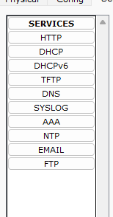

**Conclusion:**

In this experiment we learned to configure a simple college network. We explored different networking devices and how to configure them using command line interface. We also learned to configure and use different services in the network.

**Post Experiment Exercise:**

Answer following questions. *(To be handwritten on journal sheets)*

1. What are the advantages of VLAN?
2. What is the need of NAT?